|  |  |
| --- | --- |
| EGC_Black | Student Name \_\_\_\_\_\_\_\_\_\_\_\_\_\_\_\_\_\_\_\_\_\_\_  **Eastern Goldfields College**  Mathematics Methods 2015  Test 111– Calculator Free Section |
| Working Time: 40 minutes | Total Marks: 40 marks |

**Calculators and notes are NOT permitted in this section.**

***Answer all of the following questions. Show all working to obtain full marks.***

**Question One: [2, 2, 4 = 8 marks]**

Consider the follow ing Cartesian points (-2, 5) and (1,11)

(a) Determine the equation of the line passing through these tw o points.

(b) Determine the equation of a line perpendicular to the line found in part (a) and passing through the point (-6, 4)

(c) The line segment consisting of endpoints (*a,b*) and (1,11) has a midpoint of (-2, 5). (i) Determine the values of *a* and *b* .

(ii) Hence or otherw ise determine the equation of the line parallel to the line in part (b) and passing through the point (*a,b)*

**Question Two: [2, 2, 3, 3, 3= 13 marks]**

Solve each of the follow ing equations, show ing all algebraic w orking.

(a) 3(2 *x* − 4)( *x* + 6) = 0

(b) *x*2 = 9

(c) *x*2 − 2 *x* = 24

(d) −2 *x*2 −16 *x* − 32 = 0

(e) $3+x=\frac{10}{x}$

**Question Three: [3, 1 = 4 marks]**

1. Explain with reference to the discriminant in the quadratic formula, why the function

$f\left(x\right)={2x}^{2}-12x+18$ has only one root.

1. From your answer in part(a), what can you say about the turning point of this function?

**Question Four: [1, 2, 1, 1, 2, 2 = 9 marks]**

Consider the quadratic function*y* = *x*2 − 4 *x* – 5

(a) State the coordinates of the *y-*intercept.

(b) Determine the coordinates of the *x*-intercept(s).

(c) By completing the square, transform the equation of the function into the form

*y* = *a*( *x* + *h*)2 + *v*

(d) Hence or otherw ise determine the equation of the line of symmetry.

(e) State the turning point for this function and its nature.

(f) Sketch this function on the axes provided.



**Question Five: [2, 2, 2 = 6 marks]**

Consider the function $f\left(x\right)=2x-5$

1. Which of these functions are parallel to $f(x)$?

Circle or highlight all solutions.

$2x+y=10$ $y=5x-2$ $2y=4x+3$ $y-2x=-7$

1. Which of these functions have the same vertical intercept as $f(x)$?

Circle or highlight all solutions.

$3x-y=5$ $y=5x-2$ $2y=-6x-10$ $y-5=2x$

1. Which of these functions have the same horizontal intercept as $f(x)$?

Circle or highlight all soluitions.

|  |  |
| --- | --- |
| EGC_Black | Student Name \_\_\_\_\_\_\_\_\_\_\_\_\_\_\_\_\_\_\_\_\_\_\_  **Eastern Goldfields College**  Mathematics Methods 2015  Test 111– Calculator Assumed Section |
| Working Time: 20 minutes | Total Marks: 20 marks |

**Question Six: [2, 2, 3 = 7 marks]**

Calculate the value of the unknown in each of the following triangles , correct to 1 decimal place.

(a)



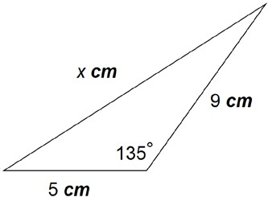(b)

(c)

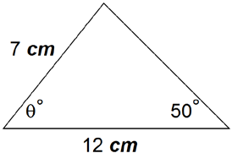

**Question Seven: [2, 2 = 4 marks]**

(a) Calculate the value of the unknown acute angle in this triangle



(b) Hence, or otherwise, determine whether the known dimensions of the triangle, that is those given in the diagram, could produce an obtuse angle triangle. Explain your reasoning.

**Question Eight: [3, 3 = 6 marks]**

Determine the equation of each of the functions drawn below.

A:

B:

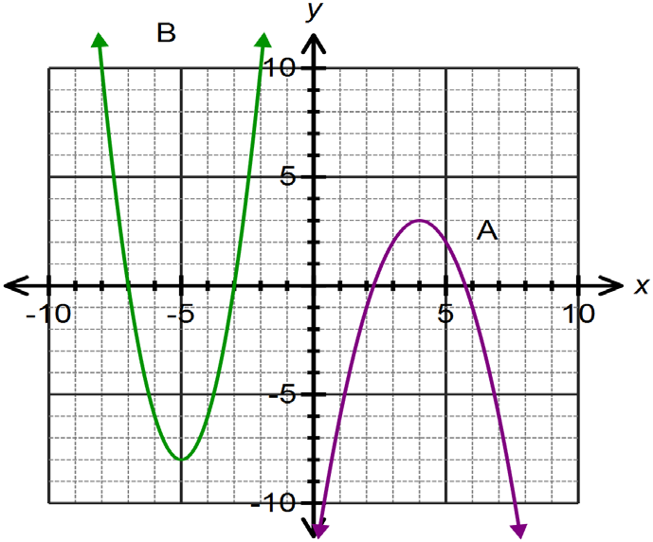

**Question Nine: [3 marks]**

Isabel throws a ball for her dog to catch. The path of the ball is parabolic and can be modeled by the equation $h=-x^{2}+4x+1.5$ where *h* is the height in metres of the ball above the ground and *x* is the horizontal distance of the ball from Isabel. If Isabel’s dog is 4m away from her, how far does he have to jump to catch the ball? Provide a sketch to illustrate your answer.